Business Process: Night Light

Contact
Business Process Owner | Billing Operations
Subject Matter Expert(s) | Billing Solutions CSRII and Sr. CSR
Key Contact | Supervisor, Billing Solutions
Key Role | Billing Solutions CSRII and Sr. CSR
Date Created | 04/21/2026

Business Process Overview
Night lights are installed on existing SMUD poles at the request of the customer if a designer determines sufficient space exist. When a night light is installed, the service notification will be assigned to Billing to complete the set up in SAP. Billing will need to create a separate premise, installation, and device location for the night light. Data entered into the installation facts determine the type/quantity of the night lights the customer will be billed.

If a night light customer reports an outage for the night light, a service notification will be created. Once the light is repaired or replaced in the field, the service notification is assigned to Billing. Billing will need to validate the information on the service notification against the information in SAP, making any necessary changes to ensure the customer is billed accurately for the appropriate night lights and quantity.

If a customer requests to have a night light removed, an email from the Contact Center is sent to the Billing inbox. Billing will create a service notification to remove the night light(s) in the field. Once the work is completed, the service notification is assigned to Billing to make the necessary changes in SAP and close the account (if necessary).

Streetlight/Nightlight Desk will send an email to the Billing inbox to consolidate multiple night light accounts at the same premise. Billing will need to close one of the night light accounts by removing the data in the installation facts and adding the night light number and type/quantity to the existing account.

Business Process Assumptions, Prerequisites, Dependencies
(Assumptions pertaining to the business process)
People | - Billing  - New Services  - GIS  - Contact Center
Process | - Verify an existing night light account already exists for the address where the new night light has been installed  - Verify the night light is not on cycle for billing  - Review as-built attached to the service notification to validate wattage  - Utilize GIS, Google/Bing maps for additional research  - Refer to correct tax code for tax-exempt customers, new addresses, and descriptive addresses
Technology | - SAP  - CRM

Process Flowchart
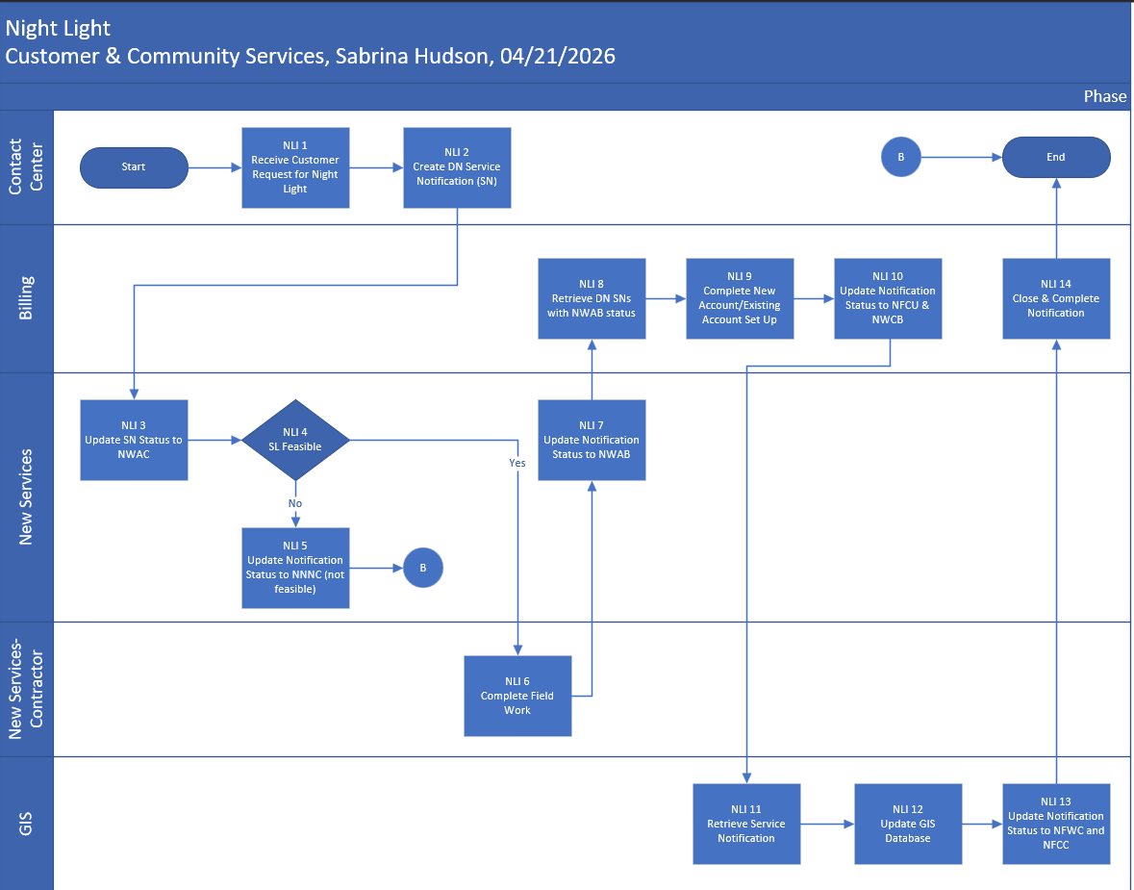

Task Description
Id | Task Description | Procedure
NLI 1 | Customer Request Night Light | - Can be phone, email or SAA request
NLI 2 | Create DN Service Notification (SN) | - Access CRM  - From the Service Notification workbench, select New/Remove/Rewire/Temp Serv SS (redirects to the PAW application)  - Enter required information
NLI 3 | Update SN Status to NWAC | - Access SAP transaction IW59  - Enter Notification Status: In process  - Enter Notification Type: DN  - Enter Notification Date: Can enter a specific date or date range  - Click execute – Outputs list of SN’s meeting search criteria  - Access SAP transaction IW52  - Enter SN #  - Click the Set Status button (checkmark and pencil), and click NWAC  - Click the green check mark, then save
NLI 5 | Update Notification Status to NNNC (not feasible) | - Access SAP transaction IW52  - Enter SN #  - Click the checkmark and pencil button, and click NNNC  - Click the green check mark, then save
NLI 6 | Complete Field Work | - Night light is installed in the field
NLI 7 | Update Notification Status to NFCU & NFWC | - Access SAP transaction IW52  - Enter SN #  - Click the Set Status button, then click NWAB  - Click the green check mark, then save
NLI 8 | Retrieve DN SNs with NWAB status | - Access SAP transaction IW59  - Enter Notification Status: In process  - Enter Notification Type: DN  - Enter Notification Date: Can enter a specific date or date range  - Enter Status: NWAB  - Click execute – Outputs list of SN’s meeting search criteria
NLI 9 | Complete New Account/Existing Account Set Up | New Account  - Access SAP transaction ZCSBH and check for existing Night Light account  - Access SAP transaction CIC0 to create a Night Light account  - Execute the Night Light Workflow  - Add the Thomas Brother Map Coordinates and Night Light # from SN  - Add Device Location notes  - Verify new Night Light Premise on Premise Environment  - Perform a move-in in CRM  - Access SAP transaction ZCSBH and view new contract  - Access SAP transaction IW52 and enter a note in the Service Notification, then update SN status  Closed/Existing Account  - Access SAP transaction ZCSBH, then access the Installation Facts  - If Wattage is not available, create a new Installation Fact including light details (i.e. Rep Factor, Rate Type, Rate Fact Group, Consumption, Time Basis, Time, Currency, Option)  - If installing the same Wattage, update existing installation fact with new time slice  - Access SAP transaction ZCSBH and click on Device Location and pencil to add Device Location notes – Light #(s)  - Access SAP transaction ZCSBH to update “Locatn Supplmnt” on the Premise for Closed Accounts
NLI 10 | Update Notification Status to NFCU & NWCB | - Access SAP transaction IW52  - Enter SN #  - Click the Set Status button and click NFCU and NWCB  - Click the green check mark, then save
NLI 11 | Retrieve Service Notification | - Access SAP transaction IW59  - Enter Notification Status: In process  - Enter Notification Type: DN  - Enter Notification Date: Can enter a specific date or date range  - Enter Status: NFCU  - Click execute – Outputs list of SN’s meeting search criteria
NLI 12 | Update GIS Database | - Add light details to GIS database
NLI 13 | Update Notification Status to NFWC and NFCC | - Access SAP transaction IW52  - Enter SN #  - Click the Set Status button and click NFWC and NFCC. Uncheck other statuses  - Click the green check mark, then save
NLI  14 | Complete Service Notification | - Access SAP transaction IW52  - Enter SN #  - Click the checkered flag  - Click the green check mark, then save

Business Rules
Id | Event Name | Business Rules
NLI 1 | Customer Request Night Light | - Must be on SMUD pole or adjacent property  - Night light must face private property
NLI 6 | Complete Field Work | - Contractor may determine the original request will not work (e.g. 60w LED was requested: however, 40w LED is installed)
NLI 11 | Complete New Account/Existing Account Set Up | - Upon assignment, NL work should be completed within 3 business days. Notify Leads if more time is needed  - If move-in is backdated, bill to current
NLI 12 | Complete Service Notification | - Once GIS has completed their work, they will update the status to NFCC. Billing runs list editing as a follow up process and completes any open notifications.

Event | Legal Requirements, Rules, and Regulations  Legal documents/ procedures/ requirements to be fulfilled before/at the specified event.
Id | Event | Legal Requirements, Rules and/or Regulations
N/A

Pain Points and Improvement Opportunities
- The whole NL research process when there isn’t a NL account- sometimes takes me a long time to just find the correct UD- and sometimes you can’t even see the exact UD # because of the access issues on the google images (private properties etc.)
- Having to manually mail letters out and most of the time not even getting a response or customers mail back the slip with nothing filled out.
- When the GIS map isn’t updated to reflect the correct UD or NL #, or the inconsistencies with GIS and SAP
- Not able to bill customers correct light fixture, for example - warehouse has 30w led & we only have 40w led in SAP. Cust is billed correct wattage but sees 40w on bill

Departments impacted by process change (Required)

Department | Type of Change(s) | Action Required
Billing Operations
New Services
GIS
Contact Center

Supporting Documentation
(Any subsequent documentation in support of this business process (i.e. business requirements, technical specs, etc.) shall be summarized in the following table.)
Document Type | Link
Night Light Process and Procedure | Night Light
Night Light Install Process Flow | Night Light Flow

Business Blueprint Amendments

Any subsequent changes to this business process blueprint after the official document approval shall be summarized in the following table. This document must be reprinted and signed by the authorized representatives.
Version | Author | Description of Change | Approval (Name/Sign) | Date
v.0 | Sabrina Hudson | Initial Draft | Approved by Maya Duarte on 4/30/26 | 04/21/2026

